**CURRICULUM VITAE**

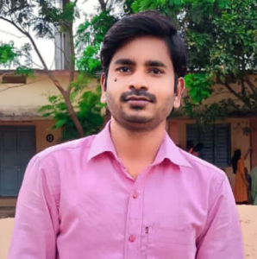**NAME :Sri. PEYYALA UPENDRA RAO**

**DESIGNATION** : Lecturer in Botany

Govt. Degree College

PALAKONDA

Andhra Pradesh, India

E-Mail: saiupendra7@gmail.com

Mob: 9494130372

**Date of Birth :**06-05-1988

**Qualification: : M. Sc, B.Ed., APSET**

**Date of Joining**   **: 03-09-2021**

**Prior to Govt. Service**  : 2 years

**Address (Res) :** Peyyalavanipeta (vill), Fareedhpeta (po), Etcherla (Mandal)

Srikakulam -532410, Andhra Pradesh**.**

**Academic Qualifications :** M.Sc., B.Ed.

|  |  |  |  |  |
| --- | --- | --- | --- | --- |
| **Qualification** | **University/Board** | **Year of Passing** | **% of marks** | **Class Secured** |
| **M.Sc.,** | Andhra university | 2013 | 78 | **1st.** |
| **B.Ed.,** | Andhra university | 2010 | 63 | **1st.** |
| **AP SET** | Andhra university | 2018 | - | - |

**Specialization: Botany**

**Teaching Experience:** 05 years for UG

**Participation in academic conferences/seminars/workshops:**

* Participated in the 3-day Training Programme on “***Internship and LMS***” From 05.01.2023 to 07.01.2023 at Nodal Resource Center (NRC), SV Govt. Degree College. Parvathipurmoraganized by Commissionerate of Collegiate Education, A.P., Mangalagiri.
* Participated in the 6-day Training of the Trainers Programme on “**English medium of Instruction, Proficiency in English**” From 12.6.2023 to 17.6.2023 at Nodal Resource Center (NRC), S.V Govt. Degree College. Parvathipurm oraganized by Commissionerate of Collegiate Education, A.P., Mangalagiri.
* Participated in the 5-day Residential Training Programme for Teachers on content Delivery and Assessment methods pertaining to Skill course for I-Semester TOT on “ Plant Nursery” at AU HRDC, Visakhapatnam. oraganized by Commissionerate of Collegiate Education, A.P., Mangalagiri.

**Academic Activities involved:**

1. IQAC Criterian-4: Member

2. Science Association Committee: Member

3. Eco-club: Member