**JALLU VISWESWARA RAO PROFILE**

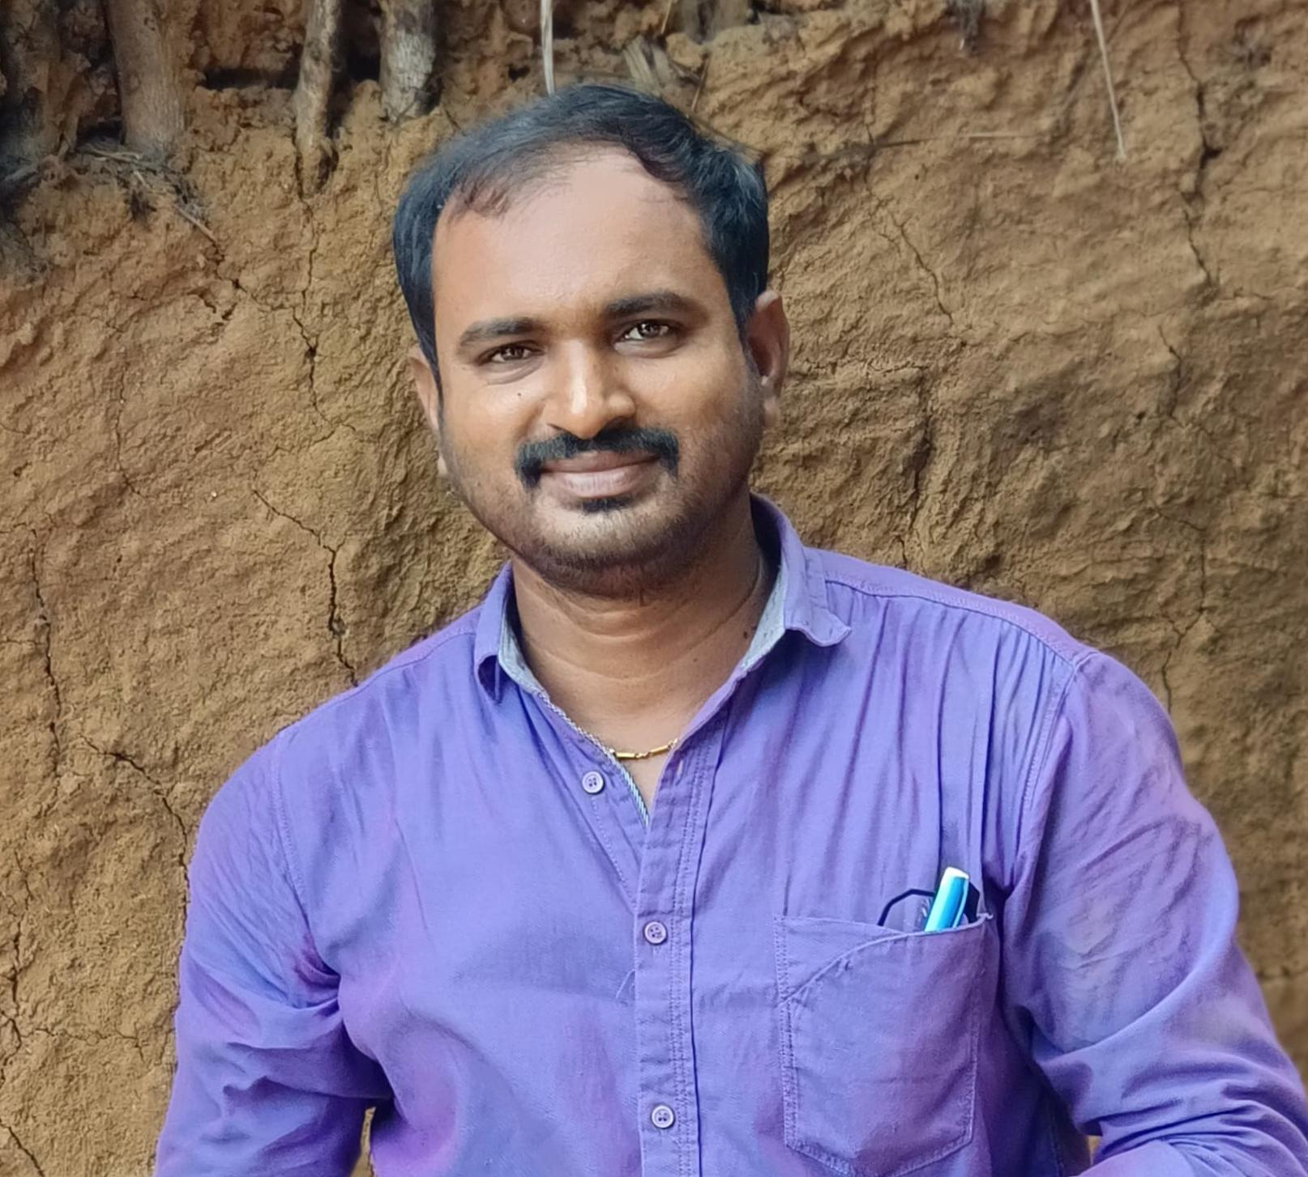

**NAME** JALLU VISWESWARA RAO

**Designation**   **:** Lecturer in PHYSICS Govt. Degree College Palakonda , Andhra Pradesh, India Parvathipuram Manyanm Dt

E-Mail: viswajallu@gmail.com

Mob: 7989482427

**Date of Birth :** 04/07/84

**Qualification :** MSC B Ed

**Date of Joining**  : 01/09/2021

**Prior to Govt. Service**  : 3 years 3 months

**Address (Res) :** S/O Appanna, Palavalasa village, Lakkupuram post, Burja mandal, Srikakulam dt, Andhrapradesh, Pin 532445

|  |  |  |  |  |
| --- | --- | --- | --- | --- |
| **Qualification** | **University/Board** | **Year of Passing** | **% of marks** | **Class Secured** |
| **MSC** | Andhra university | 2012 | 66 | **1st.** |
| **B Ed** | Andhra university | 2007 | 73 | **1st.** |

**Specialization: MSC PURE PHYSICS**

**Teaching Experience: 11 years**

**TRAINING PROGRAMMES**

|  |  |  |  |
| --- | --- | --- | --- |
| **DATE** | **NAME OF THE TRAINING** | **ORGANISED** | **TOPIC** |
| 07/12/22 TO 11/12//2022 | TOT (5 days) | APCCE | Electrical Appliances |
| 02/02/23 TO 04/02/24 | TOT (3 days) | APPCCE | INTERNSHIP and LMS |
| 05/06/23 TO 10/06/23 | TOT (3 days) | APCCE | English medium of instruction, Proficiency in English |
|  |  |  |  |