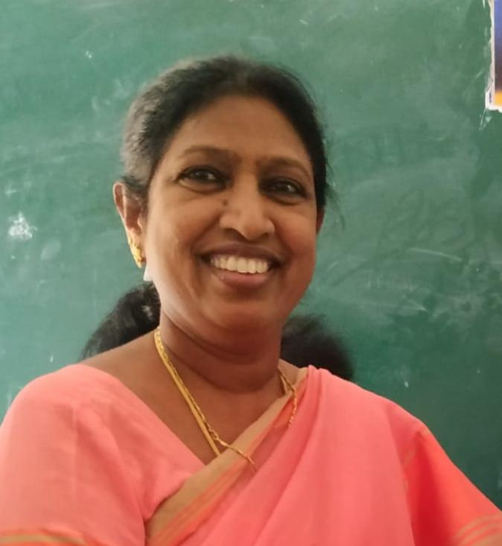CURRI VITAE

NAME :Dr .CH. M. S. KUMARI

**Designation** : **Lecturer** in TELUGU

**Address** : Government Degree College. PALAKONDA

Andhra Pradesh, India

E-Mail :[chmskumari@gmail.com](mailto:chmskumari@gmail.com)

Mob: 7382048349

**Date of Birth :** 04-03-1962

Qualification : M. A Ph. D

Date of Joining. :28-07-2001

Prior to Govt. Service : 22

**Address (Res) :Sri Sundar Residency**

Flat number 107,Oposite SBI, ramatalkies Road

Visakhapatnam 530016 ,Andhra Pradesh

**Academic Qualifications:** M.A, PhD

**Specialization. :TELUGU**

|  |  |  |  |  |
| --- | --- | --- | --- | --- |
| **Qualification** | **University/Board** | **Year of Passing** | **% of**  **marks** | **Class**  **Secured** |
| **M.A** | Andhra university | 1985 | 62% | **1st.** |
| **Ph.D** | Andhra University | 2006 |  |  |
|  |  |  |  |  |